NAME

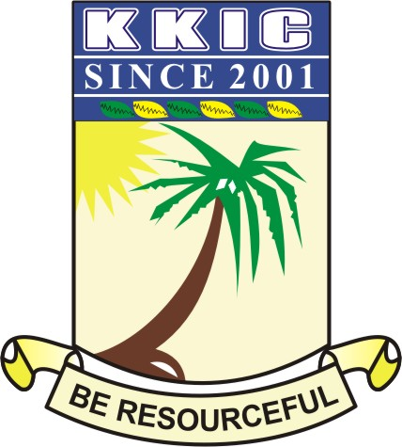

SUBJECT HISTORY CLASS JSS ONE DURATION 2 HOURS

|  |  |  |  |  |  |
| --- | --- | --- | --- | --- | --- |
| **NAME** |  | | | | |
| **SUBJECT** | **HISTORY** | **CLASS** | **JS 2** | **DURATION** | **2 HR 30 MINS** |

**PAPER 1- OBJECTIVES (20 Marks)**

**INSTRUCTION: Answer all Questions**

1. In Oyo Empire the chiefs consult ________ oracle before choosing a king.

A. Oro

B. Ifa

C. Sango

D. Obatala

2. The situation in Songhai became worst after the death of Askia Mohammed I in the year __________

A. 1677

B. 1568

C. 1528

D. 1623

3. One of these countries fought the longest civil war for 22 years.

A. Liberia

B. Somalia

C. South Africa

D. Sudan

4. Ghana was the title of the Soninke king called Aokar which means __________

A. Peace

B. Unity

C. War

D. Violence

5. During pre- colonial era Ile-ife was known as the spiritual home of the Yorubas, while ______ is referred as their administrative seat.

1. Egba
2. Oyo
3. Kwara
4. Ilesha
5. North Central
6. North East
7. South West

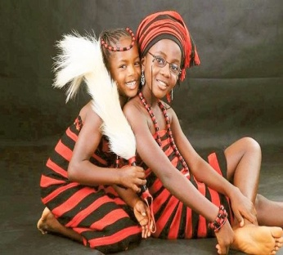

6. Which Nigerian groups are represented in the picture above?

1. The Tiv and Isoko
2. The Ibibio and Tiv
3. The Annang and Ijo
4. The Idoma and the Tiv

7. Migration of people in the pre-colonial days could be due to the following except ___________

1. same clan
2. displacement by war
3. disaster
4. famine

8. Arab geographer, Al-Fazari in his book was the first to referred to it as a land of gold in __________

A. AD 337

B. AD 666

C. AD 773

D. AD 777

9. An oral history believed that the _________ tribe is a product of marriage between the Egyptians and the Israelites.

1. Annag
2. Oron
3. Ebira
4. Efik

10. Ife is known mainly for its ---------

1. bronze work
2. stone carved work
3. brass Work
4. copper work

11. Bayajidda is the father of ___________

1. Etsu the founder of Bornu kingdom
2. Bawothe founder of Nupe kingdom
3. Bawothe founder of Igbo kingdom
4. Etsu the founder of Hausa kingdom

12. The major language of Benin people is _______

1. Bini Language
2. Edo Language
3. Ibini Language
4. Benin Language

13. The Obas in Oyo Empire are also called __________

1. The Alaafin
2. The Ogiso
3. King
4. The Oyo Mesi

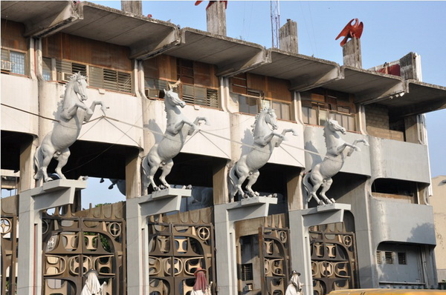

14. The above image is called TafawaBalewa square (T.B.S) is located in _________ state of Nigeria.

1. South West
2. North Central
3. North West
4. North East

15. Hausa states were located in the ____________ of Nigeria.

A. South West

B. North Central

C. North West

D. North East

16. One of the following is a similarity between the Kanmen - Borno Empire and the Hausa states

1. Both practiced non centralized system of government.
2. Both speak Hausa language
3. Both received Islam same year
4. Both practiced centralized system of government

17. An archive is a ------- source of history

1. primary
2. secondary
3. tertiary
4. none of the above

18. KanemBorno origin can be traced to the Maghumi people while that of the Hausa states to ___________

A. Bayajidda.

B. Oduduwa

C. Majji

D. Emir

19. In Mali Empire the local chieftains is called ____________

A. Kangaba

B. Dugutigi

C. Kata

D. Dugbe

20. A list of books referred to in a scholarly work typically printed in an appendix of a book is called __________

1. biography
2. bibliography
3. abstract
4. autobiography

21. Terracotta is another word for __________

1. moulded iron
2. carved stone
3. baked clay
4. beads

22. A detailed narrative of a person written by oneself is called _____________

1. biography
2. autobiography
3. personal history
4. personal story

23. Which of these cultures depict more of royalty?

1. Ife
2. Edo
3. Igbo-Ukwu
4. Nok

24. What is the name of Sango’s mother?

1. Elepe
2. Elepo
3. Elempe
4. Eleda

25. One of the following is the factor that led to the rise of Songhai Empire except __________

A. Religious factor

B. Economic factor

C. Empire size factor

D. Geographical factor

26. Islam was introduced to Kanem-Borno around the ___________ century

1. twelfth
2. twentieth
3. eleventh
4. fourteenth

27. The stories about the Yoruba people and many other Nigerian tribes were received through ------

1. science
2. legends
3. newspapers
4. town criers

28. Ife was known for bronze art works while Benin kingdom was known for ___________ and ________

1. Bronze and Copper
2. Bronze and Silver
3. Bronze and Brass
4. Bronze and Bead

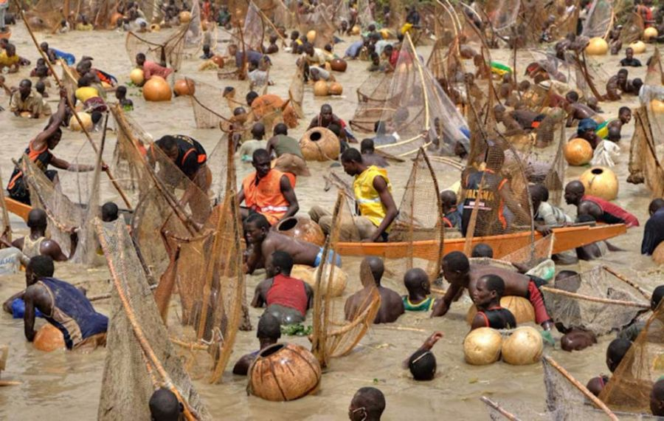

29. The image above is known as the Argungu fishing festival, it is common in ________ state of Nigeria?

1. Kano
2. Katsina
3. Kebbi
4. Kaduna

30. Ile-Ife can be found in the present day ________

1. Ogun state
2. Oyo state
3. Osun State
4. Ondo state

31.According to Igbo traditions and belief, each person is born with a guardian angel called ____

1. Chi
2. Chineke
3. Chi – Spiret
4. Chizoba

32. Which of these had non-centralised political structure in the pre-colonial era?

1. Igbo
2. Hausa
3. Kanem-Borno
4. Oyo Empire

33. Benin culture and _______ culture have similarities.

A. Nok

B. Ile-Ife

C. Delta

D. Igbo

34. In pre- crisis phase the republic of Sudan gained her independence from United Kingdom and _____________

A. Somali

B. Egypt

C. Ethiopia

D. Australia

35. Ife people speak Yoruba language while people of Benin Empire speak ___________ language.

1. Bini
2. Edo
3. Ogio
4. Bonuri

36. An archaeologist excavate ancient sites for __________

1. gold
2. artiste
3. artifacts
4. antibiotics

37. Oyo had its origin from Oduduwa the father of Yoruba while Nupe had its origin from ___________

1. Oranmiyan
2. Bawo
3. Awo
4. Banji

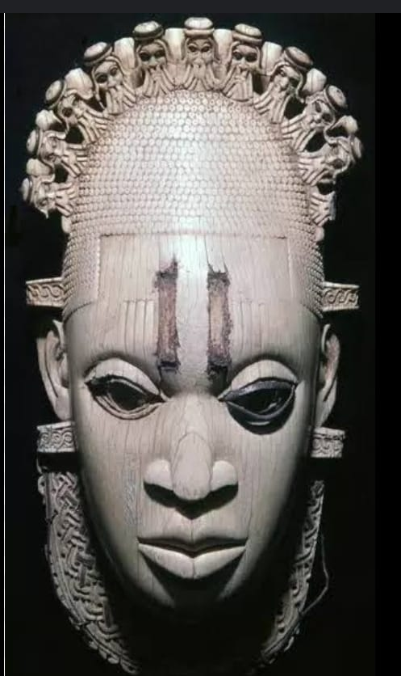

38. The above mask is related to _______ kingdom in Nigeria

1. Oyo
2. Nupe
3. Benin
4. Kanem-Borno

39.Which of the kingdoms had Ogisos as their ruler?

1. Nupe
2. Ife
3. Dlta
4. Edo

40. The word “historia” is a _______ word

A. Latin

B. Spanish

C. Hindu

D. Greek

41. Historical knowledge is important because _____

1. it makes us civilized
2. educate us on how to live like the Romans
3. it is the foundation for progress
4. our parents love history

42. A place where relics are kept is called ________

1. musuem
2. school
3. monastery
4. hostel

43. Which of the following can aid the study of history?

1. Excursions
2. Interviewing Kings of historical society
3. Watching historical movies
4. All the above

44. The first king of Ile – ife was _________

1. Oranmiyan
2. Oduduwa
3. Ooni
4. Okanbi

45. Which of these countries is home to more pyramids than Egypt?

A. Nigeria

B. Niger

C. Sudan

D. Kenya

46. The worship of Ogun, Sango, Obatala were common among the following expect __________

1. Oyo
2. Anang
3. Nupe
4. Ijebu

47. During the pre-colonial era. The name “Niger Area” was given by ____________

1. Henry Carr
2. Fredrick Lugard
3. Flora Shaw
4. Donald Duck

48. Igunnu and Egungun festivals originated from the __________ people.

1. Edo
2. Nupe
3. Igbo
4. Hausa

49. Sheikh Uthman, a muslim scholar and writer, the first king of Kangaba to be converted to Islam in the 11th century was _______

A. Baramendana

B. Bello

C. Al-Fazari

D. Soninke

50. Al-Fazari was an Arab writer and a/an ________

A. Economist

B. Biologist

C. Geographer

D. All of the above

**Theory**

**Instruction: Answer question 1 and any other three (3) questions of your choice**

(1) It is a clear fact that all the people of pre-colonial major centres of civilization interacted with themselves in various areas. Discuss their interaction on the following:

(i) Trade and commerce

(ii) Marriage

(iii) Festival **6 MARKS**

(b) Mention 4 factors for the decline of great empires in Africa **4 MARKS**

(2) Sudan is situated at the _______ part of Africa. It is known for its large coastline of about ________ Kilometres. **2 MARKS**

(b) List four history makers. **4 MARKS**

(c) Mention 4 factors for the rise of Songhai Empire.

**4 MARKS**

(3) Discuss 4 factors that led to the rise of Ghana Empire. **4 MARKS**

(b) List 6 Socio-political structure of Ghana Empire.

**6 MARKS**

(4) Explain any 4 factors for the decline of Songhai Empire. **4 MARKS**

(b) List 6 factors about Sudan. **3 MARKS**

(c) Briefly discuss Ghana Empire **3 MARKS**

(5) Mali was a great empire until her fall due to some factors. List any 4 factors. **4 MARKS**

(b) Ghana was formally known as _____________ and gained her independence in _________

**2 MARKS**

(c) List 4 factors that led to the fall of Ghana Empire

**4 MARKS**